Title: | Window Lifter  SW Component Window Lifter

History
Issue status  (Index) | Maturity/Date  (draft/invalid/valid)  (dd-mmm-yyyy) | Author  CES | Check/Release  CES | Description
1.0 | Draft  01-July-15 | Mario Rivera | Mario Rivera | Design Window Lifter

Table of Contents
1 Purpose 3
2 Definitions and abbreviations 3
3 Realization constraints and targets 3
4 SW Conceptual design 3
5 SW Component internal breakdown 4
5.1 Functional Decomposition 4
5.2 Function <Type> <function name> (type par 1, .., type par n) 5
5.3 Function <Type> <function name> (type par 1, .., type par n) 5

Purpose
This document has been created to show how Window Lifter module works. Window lifter is the module responsible to control the window movement. We have identified each functionality it means, separate two movements (Up/Down) and anti-pinch functionality. According to requirements, we have implemented two machines states to controlled direction window and velocity of each transition.

Definitions and abbreviations
Definitions
Window Lifter  Anti-Pinch | The head module to lower or raise the car windows and anti-pinch functionality  Anti-pinch is a functionality that prevents any accident with human limb.

Abbreviations
Only SW Component specific abbreviations.
References
N° | Document name | Reference
1 | Window Lifter requirements

Realization constraints and targets

In this module we have some constraints. To simulate the window movement, we use a led bar with 10 leds. The transitions between transitions is 400ms. We have two movements, Up and Down. To validate button push, needs to keep pressed more than 10ms. We have to indicate the movement (Up or Down) trough led color. We have to cases: Automatic and Manual for each movement button. Automatic mode is when you keep pressed the button between 10ms and 500ms. Manual mode is when button keep pressed more than 500ms. In another case is Anti-pinch mode, this is when the up movement is happen. When this occurs and a human limb is in the windows. Anti-pinch starts and stopping window up movement and starts down until the window is totally open.

SW Conceptual design
According to requirements, we split the module in sub-modules.
- A general function that controls all flow program. We call this function each mili second
- Define which parts are inside & outside the system boundary
- Define de interfaces between these parts, but also interfaces with neighboring systems and environment.

SW Component internal breakdown
For complex SW Components, the designer may define SW Subcomponents. Please consider also the work step "Deal with complexity" provided by the method for Detailed SW Design.
Note: SW Subcomponents are synonymous with the previous used term "Module"
Mapping to the file structure:
- Non complex SW Components should be represented by one object file.
- For complex SW Components each SW Subcomponent should be represented by one object file.
<Subcomponent decomposition if applicable>

Functional Decomposition
Overview of functions and their dependencies shown by a Static Function Tree
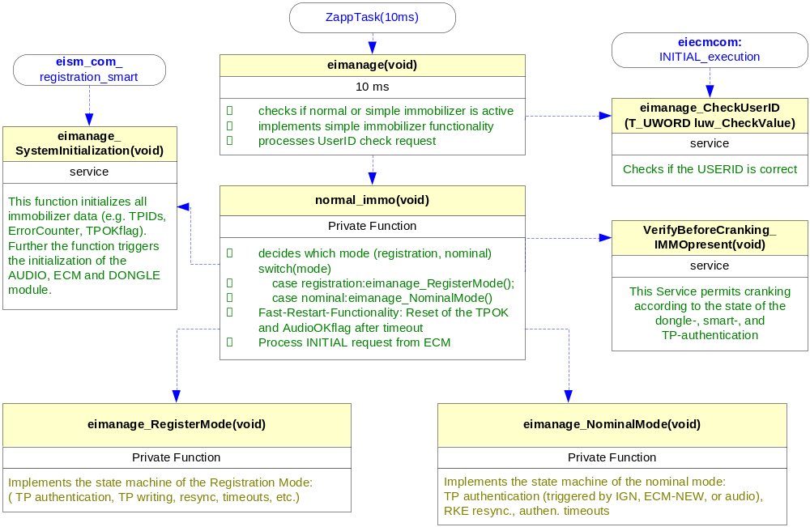
Function Description and Dynamic Behavior
Provide detailed static and dynamic description of all functions of the SW Component.
Functions which are defined in other SW Components shall only be referenced in the external interface description!
The signature description shall be done inside the function header in the source code.
For each function, the following section should be copied

Function <Type> <function name> (type par 1, .., type par n)

Description | Brief description of the function behavior and useful remarks
Parameter 1  <input| output| inout> | Give an explanation if the parameter shall be checked by the user, or if a check is implemented in the function here
Parameter 2..n
Return Value
Precondition | e.g. Function can only be called in a certain state, SW component is initialized  Relation between input parameters where applicable (Input for Module Test)
Post condition | e.g. specific State change e.g. car is locked, EEPROM Values written,  Relation between output parameters where applicable
Error Conditions

Dynamic Behavior
State Chart¹, Flow Chart¹
¹ Preferred
In this document, the dynamic behavior shall be designed on an abstract level showing the principle workflow of a function. Do not show the detailed implementation to ensure that the design description can be maintained with a reasonable effort. The target is not to show the complete detailed implementation 1:1.
The detailed design shall reflect in detail what a function is doing from a black box view. The internal details are useful on an abstract, but not very detailed level.
If the function is not complex a short textual description might be sufficient and a graphical description is not needed.
Symbol and function names shall be self explaining.
The link to the implementation may be provided by using the same names as in the design or by a comment showing the full name followed by the declaration showing the implementation.

Function <Type> <function name> (type par 1, .., type par n)
Description | Brief description of the function behavior and useful remarks
Parameter 1
<input| output| inout>
Parameter 2..n
Return Value
Precondition | e.g. Function can only be called in a certain state, SW component is initialized  Relation between input parameters where applicable (Input for Module Test)
Post condition | e.g. specific State change e.g. car is locked, EEPROM Values written,  Relation between output parameters where applicable
Error Conditions

Dynamic Behavior
State Chart¹, Flow Chart¹, Nassi Shneiderman
¹ Preferred
In this document, the dynamic behavior shall be designed on an abstract level showing the principle workflow of a function. Do not show the detailed implementation to ensure that the design description can be maintained with a reasonable effort. The target is not to show the complete detailed implementation 1:1.
The detailed design shall reflect in detail what a function is doing from a black box view. The internal details are useful on an abstract, but not on a very detailed level.
Symbol and function names shall be self explanatory.
The link to the implementation may be provided by using the same name as in the design or by a comment showing the full name followed by the declaration showing the implementation.

